DBMS

Assignment

2

Shreyansh jain

11css-59

3rd year

Computer engineering

**Catalog ( bookid, pubid, title, author )**

**Publisher ( pubid, pubname, title )**

**Order ( bookid, type, author, price, quantity,year)**

Catalog table

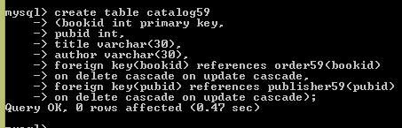

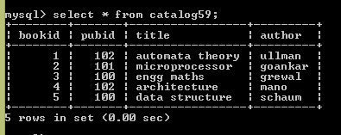

Publisher table

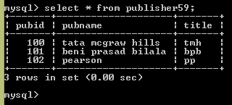

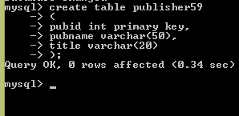

Order table

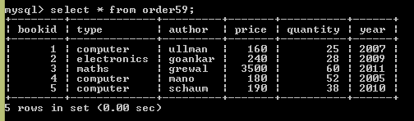

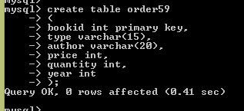

1. **Increase the price of all books of computer type by 15% published by BPB.**

Ans:- update order59 o, catalog59 c , publisher59 p set o.price = o.price + 0.15*o.price where o.bookid = c.bookid and c.pubid = p.pubid and p.title = ’bpb’ and o.type=’computer’;

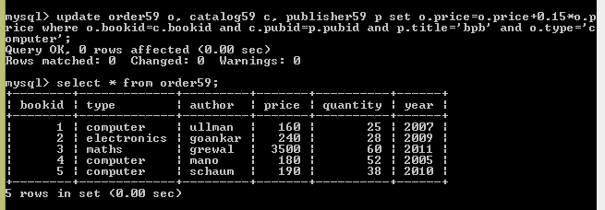

1. **Display the maximum price of books.**

Ans:- select max(price) from Order59;

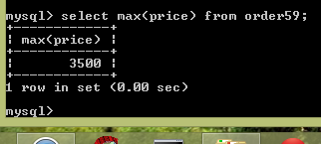

1. **Display the second highest price of books.**

Ans:- select max(price) from Order59 where price not in (select max(price) from order59);

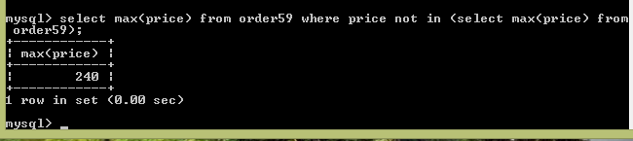

1. **Get the pubid, pubname of all the books whose quantity > 50.**

Ans:- select p.pubid, p.pubname, c.title, o.quantity from Publisher59 p , Order59 o, Catalog59 c where p.pubid = c.pubid and c.bookid = o.bookid and o.quantity > 50;

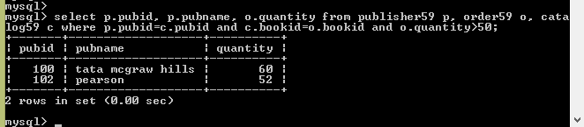

1. **Get total price of all the books published in year 2005.**

Ans:- select sum(price*quantity) from Order59 where year=2005;

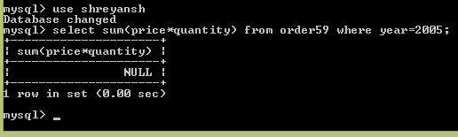

1. **Get the pubname, author of all the books.**

Ans:- select p.pubname, c.author from Publisher59 p,Catalog59 c where p.pubid=c.pubid;

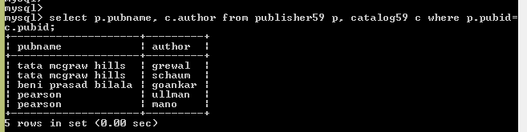

1. **Find name of all the author whose second character is ‘n’.**

Ans:- select author from Catalog59 where author like ‘ _n%’;

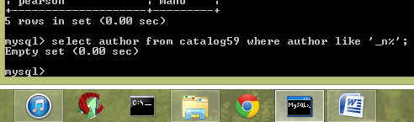

1. **Change year of publishing of all the books from 2005 to 2008 where quantity > 10.**

Ans:- update Order59 set year=2008 where year=2005 and quantity>10;

